Advertising and Sponsorship Publication and Ad Specifications

Business Credit Magazine General Information
Software: CC 2022
Printing process: Web full-run
Trim size: 8.125 x 10.875”
Number of columns: 3
Number of pages: 40, plus cover
Binding method: Saddle stitched
File Formats
Macintosh-based, primarily using Adobe InDesign, Photoshop and Illustrator.
A hi-res PDF format with fonts embedded is preferred.
No Microsoft applications or PDFs created from Microsoft applications.
File Submission and Print Guidelines
• Submit art through FTP, or by email (if less than 10MB).
• All images must be at least 300 dpi. Do not use GIFs or JPEGs.
• All fonts must be provided or embedded in files.
• Images and text must be in CMYK or grayscale. All specified colors should not exceed a total value of
300% (the total percent of C+M+Y+K when added).
• Crop marks must be in place, colored as “registration” and should be incorporated with an offset of 12pts.
• Line weight should not measure less than 0.25pt.

Non-Bleed Standard Ad Dimensions
Full page | 7.125 X 9.875"
½ vertical | 3.75 X 9.875"
½ horizontal | 7.125 X 5"
1/3 vertical | 3.75 x 6.5"
1/3 horizontal | 7.125 x 3.25"
¼ vertical | 3.75 x 5"

Bleed Dimensions
Add 0.125” bleeds all around with trim marks
Full page – Trim size | 8.125 X 10.875”
Spread – Trim size | 16.25 X 10.875”

File Specifications for Digital Ads
Acceptable file formats: JPEG, PNG, or PDF with fonts embedded. Flash programs are not accepted due to format viewing restrictions. All digital files should be set at 72 dpi. Your ad should display properly no matter what background color exists on the web page. Current web page background color is white. DO NOT submit
an ad with a transparent background.

Digital Ads
Business Credit Magazine | 1400 X 400 or  800 (h) x 1200 (v)
eNews Weekly Update | 940 X 1400
Credit Essentials | 1400 X 400
NACM home page slider | 3604 X 930
Week in Review | 1400 X 400

If you have any questions regarding these specifications, please contact Robin An or Tina Widzbor at
410-740-5560.
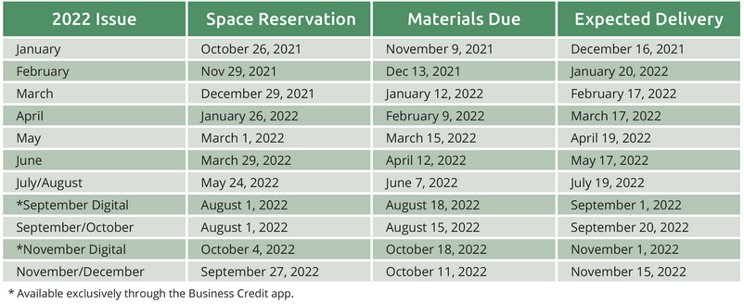

eNews ad specifications:
NACM’s eNews Weekly Update is distributed Thursdays via email to more than 18,000 members and subscribers. It is also posted on the NACM website for one week. There is a limit of two featured ads in each issue (listed on a first come, first served basis)

The ad size for eNews is 940 X 1400 pixels
Artwork and accompanying URL must be received by Tuesday, 5:00pm eastern time, the week of the issue.
Acceptable file formats: GIF, HTM, JPEG, TIFF, PDF, Animated
GIF. Flash programs are not accepted due to format viewing restrictions. Your ad should display properly no matter what background color exists on the web page. Current web page background color is white. DO NOT submit an ad with a transparent background.

ePostcard:
Acceptable file formats: JPEG or GIF or PNG
Include web link/address
Specifications: 550px wide by 350px high
OR
Provide company logo and text and we will arrange

Attendee Reminder email and Attendee Thank You email
600 pixels wide
135 pixels high
Submit as PNG or JPEG file
Include web link

Sponsorship Packages
Logo specifications: EPS file. If not available, either JPEG or TIFF in high resolution (300 dpi), at least 5” wide.

NACM must approve any content (written or artistic) that will be published, printed, displayed or distributed as part of our Advertising/Media and Sponsorship Packages. NACM may reject, cancel or request alternation to any material submitted as a part of this process at its sole discretion.

Collection agencies are ineligible to participate in any promotional, advertising or sponsorship opportunities.

